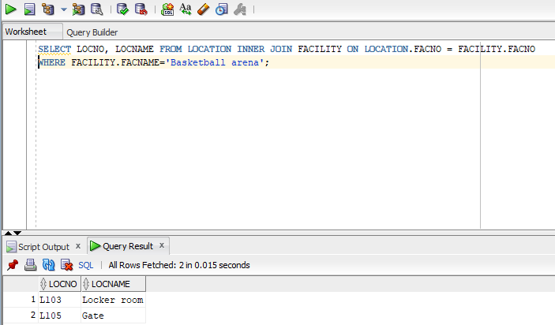
SELECT LOCNO, LOCNAME FROM LOCATION INNER JOIN FACILITY ON LOCATION.FACNO = FACILITY.FACNO WHERE FACILITY.FACNAME='Basketball arena';

